|  |
| --- |
|  |
| Finding Dawn |
| If you move, you survive |
| Version 0.3  All work Copyright © 2018 by Silly Arts Games.  All rights reserved. |
| **Harshil Mehta**  **Pragnesh Patel**  **Dylan Schmidt-Cunningham** |
|  |

|  |
| --- |
| March 11th 2018 |

**Table Of Contents**

***Version History*** 3

***Game Overview*** 4

***Game Play Mechanics*** 4

***Camera*** 4

***Controls*** 4

Saving and Loading 5

Interface Sketch 5

Menu and Screen Descriptions 5

Game World 6

Levels 6

Characters 6

Enemies 7

Weapons 8

Items 8

# Version History

Github Repository : https://github.com/harshilme2/Game-Project

**Version 0.3**: March 11, 2018

Project Setup

Total Commits - 1

# Game Overview

*It been long time since player has seen the day light. Fear of outside war kept the player trapped for long time. The place has become hard to survive and it’s time for player to move out for his survival. The goal of this game is to find your way out of dungeon.*

# Game Play Mechanics

* *Moving in left-right-up-down*
* *Use weapon to kill the opponent*
* *Kill enemies by shooting/knife*
* *Find your way out through dungeon*
* *Collect weapons on the way to use against strong enemy*

# Camera

*This game has Top-Down camera view.*

# Controls

*This game will use arrow keys and Space bar. Alternatively, will use ASDW keys for movements.*

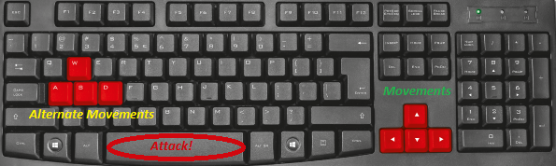

# Saving and Loading

*The game will have checkpoints. If the player dies, it will utilise the life and start from last check point. The checkpoints will be somewhere in center of map. One checkpoint per map.*



# Interface Sketch

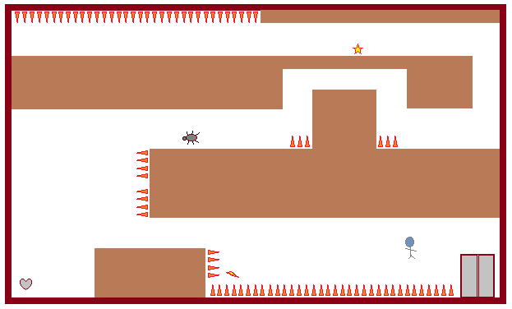

# Menu and Screen Descriptions

*There will be timer and health given for player. Player enters from one end and exits on other end finding his way out. There will be time shown in blue color and health in red as shown in fig 7.1*



**Fig 7.1**

# Game World

*It’s an underground old tunnel which was used for mining. It was abandoned for long time. My.Ribs was aware of it so went there to hide from outside war. Unfortunately, due to big explosion the main entry point of tunnel was blocked and there was no way out. Mr.Ribs has supplies and decided to stay inside till war gets over, but he cannot survive inside for long so now its time for him to find the way out. The tunnel somehow had flowing water which gave him hint that if water can come inside, then he can take it as clue to go out.*

# Levels

*There will be three levels.*

*Level 1: Supply room – Where he used to live and had stock up all his belongings. He had weapons too here which he needs to remember to collect. There are some areas where he has not been and one of the necessity will be to pass through it. This room is with supply boxes and wall.*

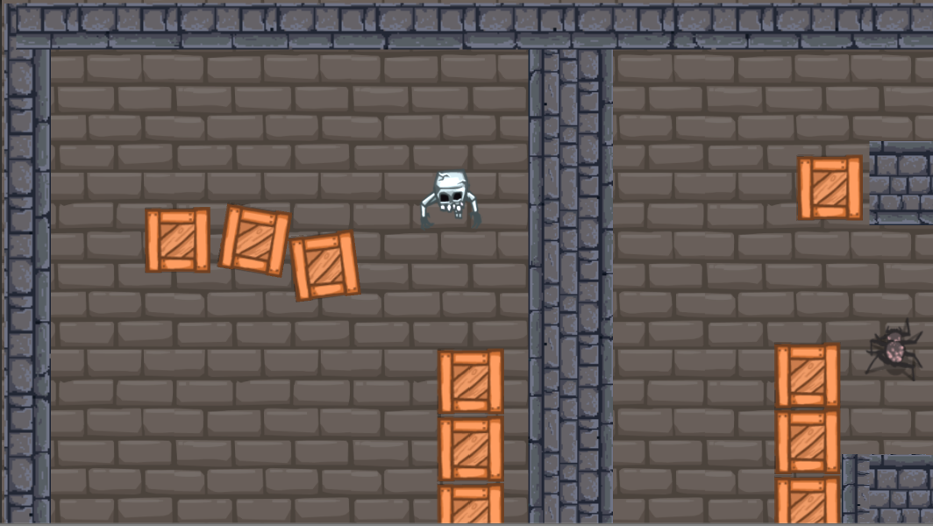

*Level 2: Scary room – This is the room where he had never been, but he knew it existed. It has dangerous Spider. There will be a weapon and energy boost hidden on this level. This room has spikes.*

*Level 3: Outside room – This room gives him hope as he sees first daylight from end of the room. But wait! There are giant bats that resides there.*

# Characters

*Characters will be a human skeleton. His name is Mr.Ribs! He has been stuck for long, he looks like skeleton.*

# Enemies

***Giant beetle****:*

*health: high*

*damage: medium*

*speed: slow*

*Its slow speed leaves it vulnerable to ranged attacks. Just dodge them and find safe passage!*

***Giant spider****:*

*health: medium*

*damage: medium*

*speed: medium*

*The biggest immediate threat of the three enemy types, these enemies should be a player's top priority...*

***Poison spider****:*

*health: low*

*damage: high*

*speed: medium*

*The biggest immediate threat of the three enemy types, these enemies should be a player's top priority...*

***Bat****:*

*health: low*

*damage: low*

*speed: fast*

*Generally just a nuisance, it's most dangerous in narrow halls with nowhere to go to dodge, when in a group, or when paired with tougher enemies that keep the player distracted*

***Giant Bat****:*

*health: very high*

*damage: medium*

*speed: medium*

*The boss at the end of the third level, it can periodically summon more bats to help it fight.*

# Weapons

*Knife, sword*

# Items

*Spikes, Collectables like heart for health, Energy for timer.*